Directions to Minnekirken - Norwegian Lutheran Memorial Church

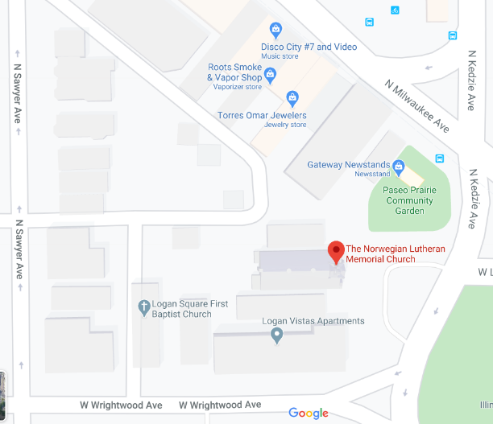
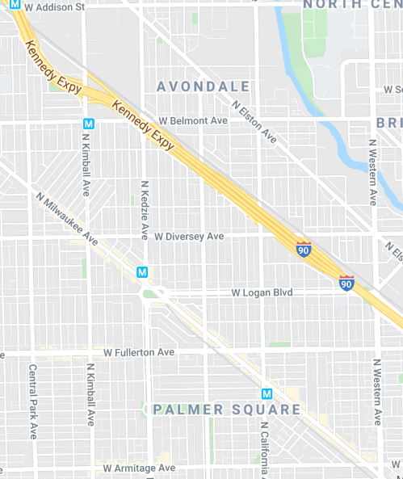
The Norwegian Lutheran Memorial Church

From O’Hare (12.5 miles):
- 1Get on I-190 E
- Take I-90 E to N California Ave. Take exit 46A from I-90 E (estimated 11 min /11.0 mi)
- Follow N California Ave and W Logan Blvd to the church (estimated 4 min /0.9 mi)
- Merge onto N California Ave (0.3 mi)
- Turn right onto W Logan Blvd (0.5 mi
- Use the right 2 lanes to turn left to stay on W Logan Blvd (98 ft)
- Destination will be on the Right

From Downtown:
- Follow I-90 W/I-94 W to W Diversey Ave. Take exit 46B from I-90 W/I-94 W (5 min/4.2 mi)
- Turn left onto Diversey Ave (0.7 mi)
- Turn left onto Kedzie Ave.(0.2 mi)
- Destination will be on the Right

Using Public Transportation:
- The CTA Blue-line “Logan Square” stops is adjacent to the church
- Connections with CTA Buses #56 or #76

To Parking Lot:

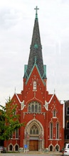
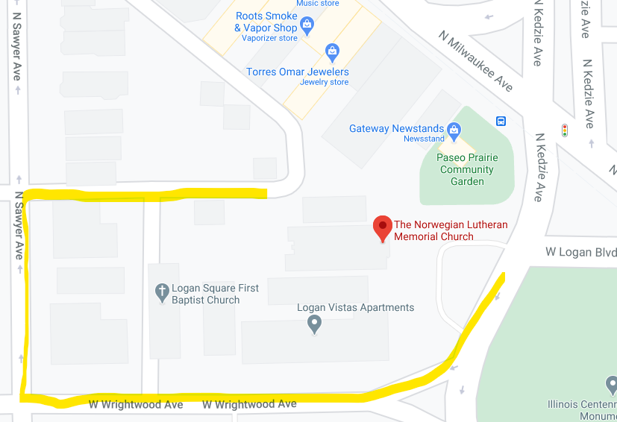

From Kedzie:
Turn right on Wrightwood (W)
Turn right on Sawyer (N),
Turn right at first alley (E),
Proceed straight to Church Parking Lot at the end of the alley.

From Kimball:
Turn left on Wrightwood (E)
Turn left on Sawyer (N),
Turn right at first alley (E),
Proceed straight to Church Parking Lot at the end of the alley.

